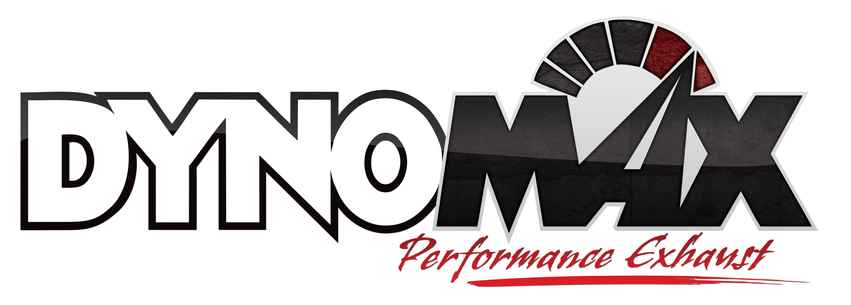
For More Information:

Christine Bowser, Pinnacle Media
(330) 688-3515 chrissy@pinnmedia.com

FOR IMMEDIATE RELEASE

DYNOMAX® EXHAUST SYSTEM DELIVERS PERFORMANCE GAINS ON DODGE CHARGER & CHRYSLER 300C MODELS

Las Vegas, NV, Oct. 30, 2012 – The new cat-back system from Tenneco’s DynoMax® performance exhaust brand for 2011-2012 Dodge Charger/Chrysler 300C R/T 5.7L Hemi V8 cars adds horsepower and torque to the popular models. Engineered for “Pure Unadulterated POWER,” the new DynoMax exhaust system (Part no. 39518) is available now at performance retailers nationwide.
DynoMax performance exhaust is one of North America’s leading brands of dyno-proven exhaust technologies for late-model and classic muscle cars, diesel and gas trucks and sport utility vehicles and sport compact/European cars. DynoMax products are manufactured and marketed by Tenneco (NYSE: TEN).
The DynoMax Charger/300C exhaust system posted a gain of 13 horsepower and 24-ft. lbs. of torque in recent dyno testing. The new system includes 2.5-in. high-quality, 409-grade, OE-style stainless steel piping for extended protection against corrosion.
This system also features a pair of stainless steel Super Turbo™ mufflers, a unique DynoMax design that provides a true performance tone with minimal resonation. These mufflers include exclusive, patented flow directors that channel exhaust flow and eliminate turbulence; internal flow tubes to reduce backpressure and improve flow; and fiberglass matting to help absorb unwanted resonance. Super Turbo mufflers flow up to 700 standard cubic feet per minute (SCFM).
Each system includes necessary OE-style rod hangers, six stainless steel band clamps and additional hardware plus handy, easy-to-follow installation instructions.
Covered by a limited lifetime warranty, each system is backed by an exclusive 90-day Performance and Sound Guarantee®. The 90-day Performance and Sound Guarantee allows an enthusiast to try the product for 90 days. If within the first 90 days of ownership the consumer is unhappy for any reason, they can return the products for a full refund of the purchase price. Additional details and restrictions apply and can be found at www.DynoMax.com.
For more information about DynoMax products, please visit www.DynoMax.com, contact your nearest DynoMax supplier or call 1-734-384-7806. For the name and location of your nearest DynoMax performance exhaust retailer, check out the dealer locator at www.DynoMax.com.
Tenneco is a $7.2 billion global manufacturing company with headquarters in Lake Forest, Illinois and approximately 24,000 employees worldwide. Tenneco is one of the world’s largest designers, manufacturers and marketers of emission control and ride control products and systems for the automotive and commercial vehicle original equipment markets and the aftermarket. Tenneco markets its products principally under the Monroe®, Walker® and Clevite® Elastomer brand names.
###

