
PRESS RELEASE
Contact: J.R. Granatelli
Granatelli Motor Sports, Inc.
1000 Yarnell Place, Oxnard, CA 93033
805-486-6644 (phone), 805-486-6684 (fax)
www.GranatelliMotorSports.com
jrgranatelli@granatellimotorsports.com

For Immediate Release

Granatelli Twin Turbo System for 1998-02 LS1 Camaros & Firebirds
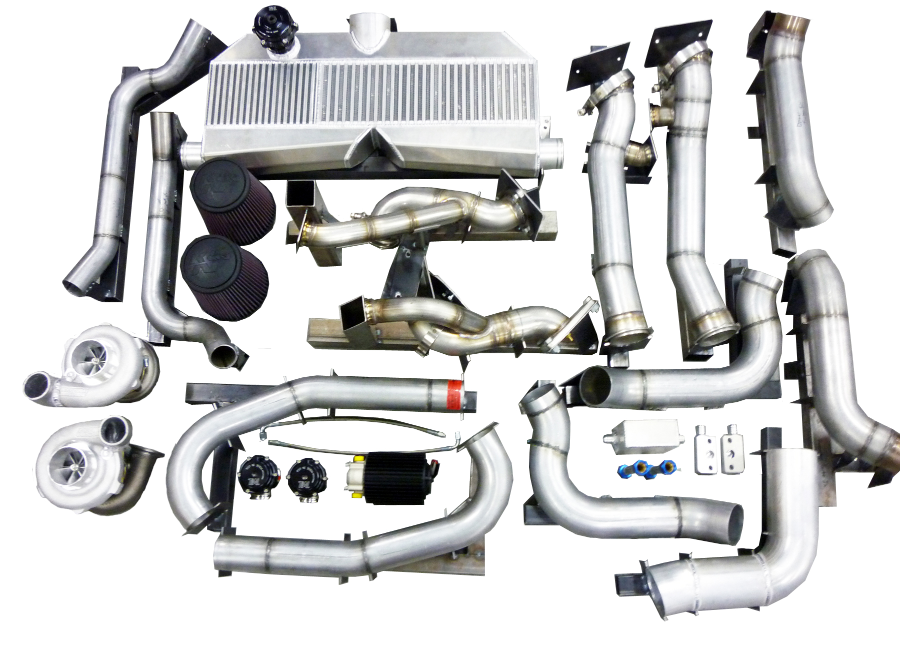
Oxnard — January 7, 2013 — Granatelli Motor Sports is proud to announce the availability of the Granatelli Twin Turbo system for 1998-02 LS1 Camaros & Firebirds. The system produces 450RWP @ 7 PSI using 91 California grade octane fuel but is capable of 1,100RWP on a professionally built engine. (Recent testing showed 815 rwhp on a low compression 427 LsX engine using 91 California grade octane fuel at 15 psi) The system features near-ZERO turbo lag, instant tire shredding power, superior fit and finish and all OEM quality. The kit is 100% complete, additional engine modifications recommended after 9 PSI (call for details). The kit includes twin 62/66mm PTE6266 T3/T4 housing Precision turbos, twin 38mm TiAL MVS waste gates, Granatelli/TiAL 50mm compressor bypass valve, stainless steel exhaust components through out the system, powder coated tubing from turbo to intercooler and from intercooler to throttle body as well as a large front mount air to air intercooler core. Installation requires only moderate mechanical skills and can be completed within 12 hours. For more information, please call 805-486-6644 or visit www.granatelllimotorsports.com.
###

