For Immediate Publication:
Contact: Tommy Lee Byrd
Coker Tire
423-648-8526
tommyleeb@coker.com

ADD TRADITIONAL STYLE TO YOUR HOT ROD WITH WIRE WHEELS FROM COKER TIRE

Coker Tire Offers A Full Line of Hot Rod Wheels

Chattanooga, TN – No matter how you define the term “hot rod”, this type of vehicle needs a good-looking wheel and tire combination. Coker Tire has been supplying hot rodders with a great selection of tires for years, but most folks don’t realize Coker also offers a wide variety of wheels, not only for classic cars, but also for hot rods of all shapes and sizes. This line of Hot Rod wheels from Coker Tire includes Hot Rod Wire wheels, which are made in the USA by Roadster Wire Wheel.
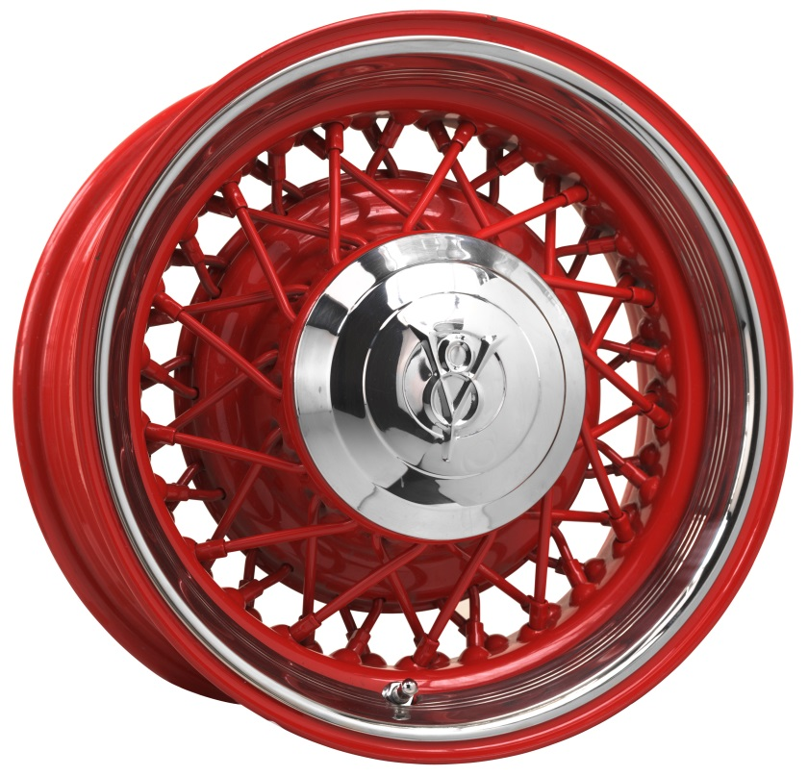
Coker Tire offers its Hot Rod Wire wheels in many different sizes. You can mix and match them to your liking and pick out a set of tires to fit the theme. All of Coker Tire’s Hot Rod wheels feature four options for bolt patterns: 5 x 4-1/2, 5 x 4-3/4, 5 x 5 and 5 x 5-1/2. All Hot Rod Wire wheels from Coker Tire are available in primed or chrome-plated finish, but there is also the option for custom powder coating, with 12 available colors.

Hot Rod Wire wheels are available in a number of sizes from 14 to 20 inches in diameter, and widths from 3 to 10 inches. They’re an excellent option for cars built from ’28-48, but they fit other applications as well. Several center cap and trim ring options make this wheel versatile to many makes and models. It features a 52-spoke design that resembles the O.E. style wire wheels of yesteryear, with modern sizing options and bolt patterns to fit most applications. Hot Rod Wire wheels accept a ’32-35 Ford O.E. center cap.

If you'd like more information about Coker Tire’s line of Hot Rod Wire wheels, please visit www.cokertire.com to place an order, request a catalog or simply to browse the product range. Coker's toll free order line is 1-800-251-6336. If in the area, feel free to stop by Coker Tire Company's headquarters, which is located at 1317 Chestnut Street in historic downtown Chattanooga, Tennessee. Hours are 8 AM - 5 PM Monday through Friday and 8 AM - Noon on Saturday.

