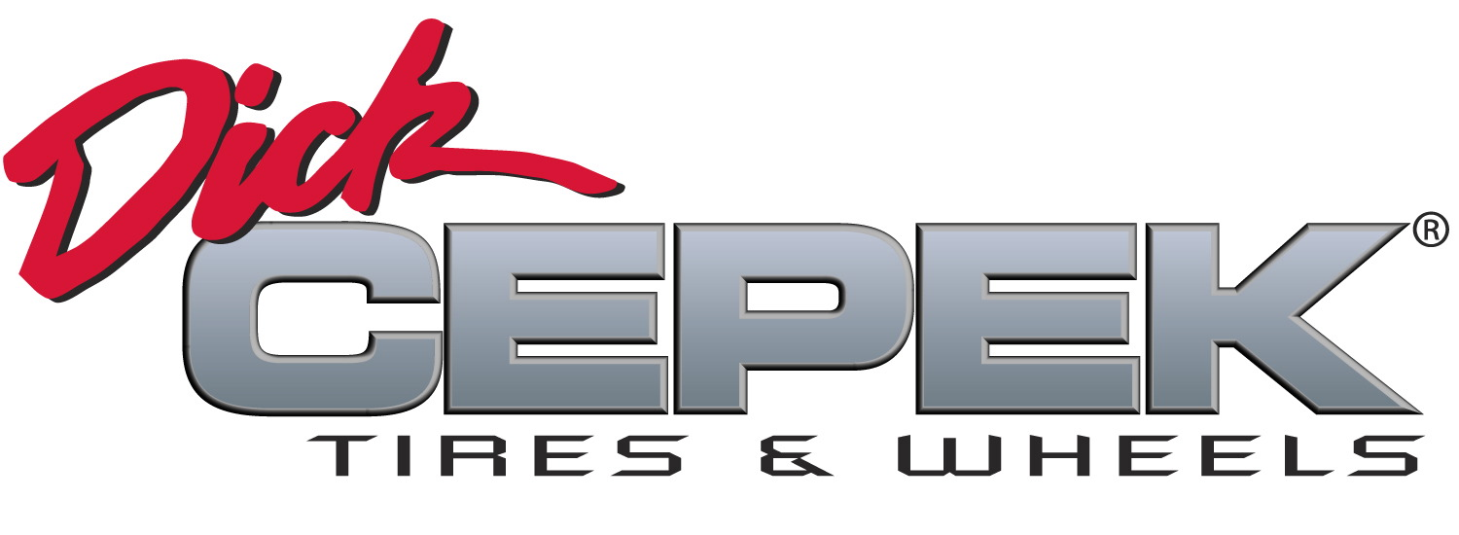
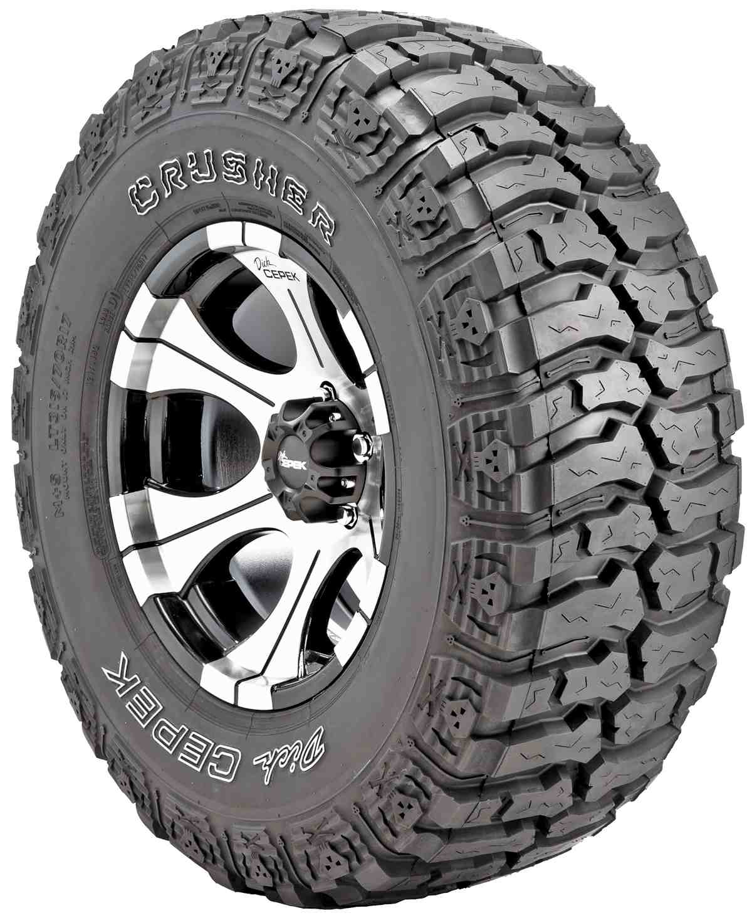

Contact :

DICK CEPEK TIRES
& WHEELS
4600 Prosper Drive
Stow, OH 44224
Don Sneddon, Advertising Manager
800-222-9092 ext. 3750
or 330-928-9092
www.dickcepek.com

DICK CEPEK® TIRES & WHEELS OFFERS THE ULTRA-AGGRESSIVE CRUSHER™ RADIAL OFF-ROAD TIRE

STOW, OH – The ultra-aggressive Crusher™ radial from Dick Cepek Tires & Wheels is a tough radial featuring a dynamic tread pattern specifically designed for demanding off-road traction as well as excellent handling on the street. Off-road enthusiasts will benefit from the responsive and capable three-ply sidewalls and “skull-and-cross-bones” SideBiters® that can take on the toughest terrain.

Advanced radial construction and superior uniformity allow for maximum ride comfort while also allowing for a higher load rating and increased towing capacity. The high-void, self-cleaning tread lugs provide superior performance in mud or snow, and the extra wide footprint and specialized tread pattern deliver added traction without added road noise.

For more information on the Crusher, including sizes and part numbers,
please visit Dick Cepek Tires & Wheels at http://www.dickcepek.com/tires.php.

About Dick Cepek Tires & Wheels
Founded in 1963 by off-road enthusiast Dick Cepek, the Dick Cepek brand has always taken great pride in providing quality on and off-road products for truck, SUV and 4x4 owners. From its humble beginnings to its high-tech tire manufacturing facilities around the country today, the Dick Cepek legend lives on in the quality products that bear his name. For more information, visit http://www.dickcepek.com

