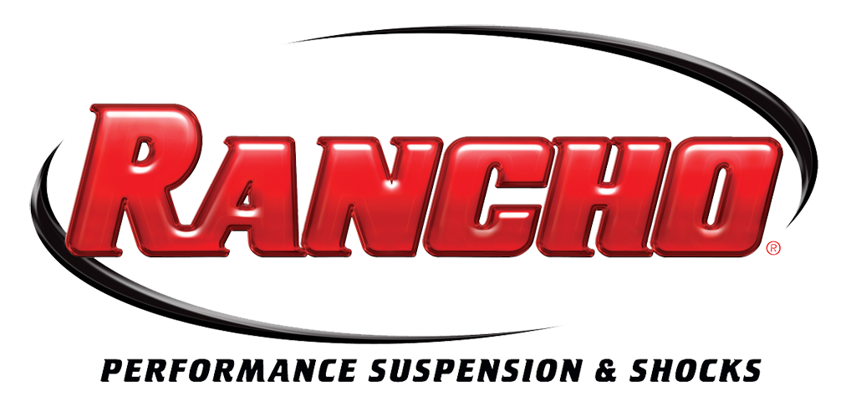
For More Info:
Christine Bowser, Pinnacle Media
(330) 688-3515, chrissy@pinnmedia.com

FOR IMMEDIATE RELEASE

RANCHO® PERFORMANCE SUSPENSION SYSTEM ADDED FOR 2011-2013 FORD F-250/F-350 SUPER DUTY TRUCKS

Rancho®, the performance suspension and shock brand of Tenneco (NYSE: TEN), has added a 4-in. sport suspension system (Part no. RS66551B) for 2011-2013 Ford Super Duty F-250/F-350 diesel trucks to its product line.
The new sport suspension system will be available in early 2013 at leading performance retailers nationwide. Chris Gauss, national sales manager, performance products, Tenneco, said, “Rancho engineers continue to add exciting, exclusive design enhancements, and this latest kit for the Super Duty diesel is no exception.”
Compatible with 37-in. tires, the latest Rancho sport suspension system for the Ford F-250/F-350 diesel truck includes a newly engineered forged pitman arm to enhance ride and handling while maintaining proper suspension geometry. Made in the United States, the Rancho suspension system also includes new track bar drop brackets and radius arm drop brackets.
This easy-to-install, bolt-on kit allows for easy upgrade to the stock radius arms. Each kit includes a highly detailed, full-color product installation guide. A new front coil spring kit and rear block kit is required to finish the installation. The system is compatible with stock tire and wheel packages.
The new Rancho sport system for 2011-2013 Ford F-250/F-350 trucks is backed by the Rancho brand’s limited lifetime warranty, see www.GoRancho.com for additional details.
The new sport kit is an additional option from Rancho for 2011-2013 Ford F-250/F-350 truck owners. The Rancho brand also offers a 4-in. suspension kit (Part no. RS6524B) and leveling kit (RS6525B). More details can be found at www.GoRancho.com.
To learn more about the Rancho system and components for late-model Ford F-250/F-350 diesel trucks, please visit www.GoRancho.com, contact your nearest Rancho dealer or call 1-734-384-7806. To locate your nearest Rancho authorized dealer, please use the “Where to Buy” tab at www.GoRancho.com to generate a list of nearby stores in your selected regional and other online retailers.
The Rancho suspension and shocks brand is one of the performance aftermarket’s leading brands. The Rancho brand of performance suspension and shock absorbers is manufactured and marketed by Tenneco (NYSE: TEN) and headquartered in Long Beach, Calif.
Tenneco is a $7.2 billion global manufacturing company with headquarters in Lake Forest, Illinois and approximately 24,000 employees worldwide. Tenneco is one of the world’s largest designers, manufacturers and marketers of emission control and ride control products and systems for the automotive and commercial vehicle original equipment markets and the aftermarket. Tenneco markets its products principally under the Monroe®, Walker® and Clevite® Elastomer brand names.
###

