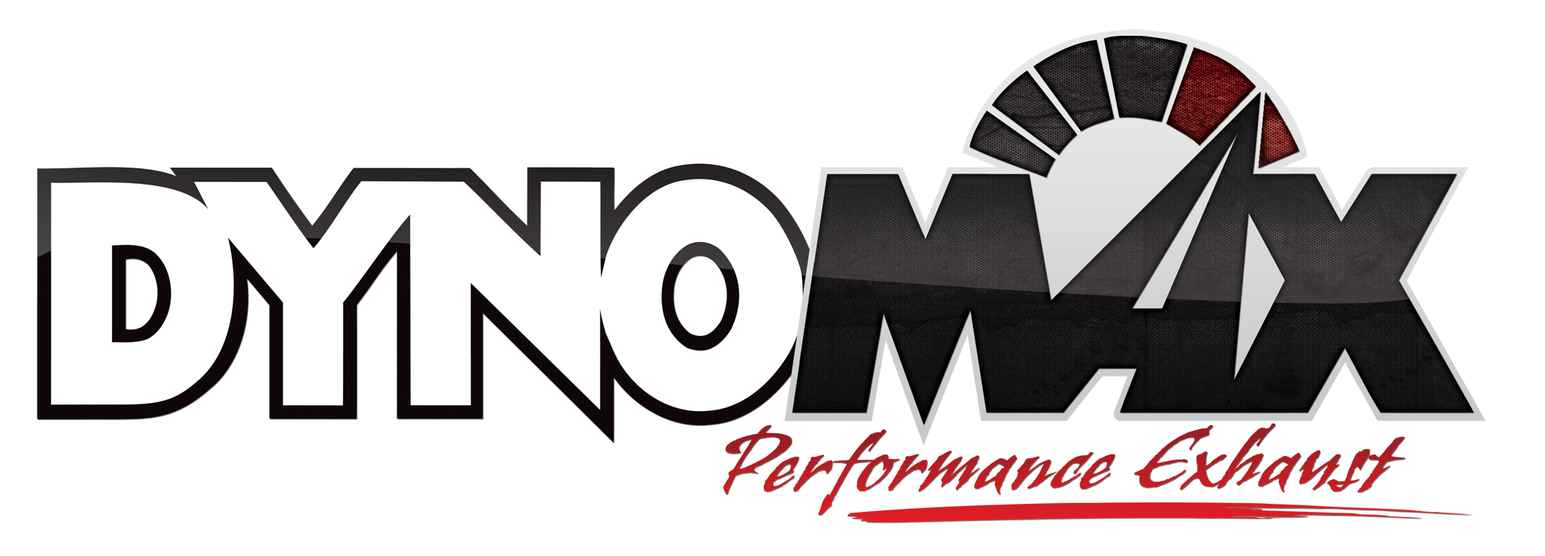
For More Information:

Christine Bowser, Pinnacle Media
(330) 688-3515 chrissy@pinnmedia.com

FOR IMMEDIATE RELEASE

DYNOMAX® EXHAUST SYSTEMS ADD NEW OFF-ROAD COVERAGE TO POPULAR JEEP PLATFORM

After the release of the industry’s first off-road “Evolution Competition” system for Jeep vehicles this past spring, Tenneco’s DynoMax® performance exhaust brand has added additional coverage of the popular design to fit 2012 Jeep Wrangler Unlimited 3.6L V6 platforms (Part no. 39522).
Available at performance retailers nationwide, the DynoMax “Evolution Competition” system was designed for extreme off-road driving and rock crawling and is ideal on lifted JKs. Engineered to dump the exhaust in front of the rear axle, the DynoMax kit provides additional space and flexibility to run an off-road suspension system. This kit is for off-road use only. The original Evolution Competition kit was designed in collaboration with Off-Road Evolution, Fullerton, Calif.
Each of the Evolution Competition systems were engineered for the 2012 Jeep Wrangler Unlimited 3.6L V6 vehicle and utilize a stainless steel DynoMax® Ultra Flo™ polished round muffler. This muffler – one of the DynoMax brand’s most popular designs – is engineered to maximize exhaust flow and provide a unique, sporty sound while fitting conveniently into a smaller, tighter space. The Ultra Flo muffler design is DynoMax-proven to support up to 2,000 CFM and 2,000 horsepower through a straight design that ensures unrestricted exhaust flow and reduces backpressure.
The system for the 2012 Jeep Wrangler 3.6L V6 vehicle includes 2.5-in. all 409-grade stainless steel, mandrel bent pipe for extended protection against corrosion, and two stainless steel 2.5-in. band clamps. Like all DynoMax exhaust kits, the JK system includes other necessary hardware and instructions for an easy, bolt-on installation. Tenneco also released a similar DynoMax kit for 2007-11 Jeep Wrangler 3.8L V6 models (Part no. 39516) that is available at performance retailers nationwide.
Each and every DynoMax product is built to the brand’s theme, “Pure Unadulterated POWER,” and is backed by an exclusive 90-day Performance and Sound Guarantee. The 90-day Performance and Sound Guarantee allows enthusiasts to try the product for 90 days. If within the first 90 days of ownership the consumer is unhappy for any reason, they can return the products for a full refund of the product’s purchase price. The series also is backed by the DynoMax brand’s limited lifetime warranty; see www.DynoMax.com for further details on the Safe & Sound® guarantee and limited warranty.
A leader in aftermarket performance exhaust products for Jeep vehicles, DynoMax Performance Exhaust products are manufactured and marketed by Tenneco (NYSE: TEN). The DynoMax brand is one of North America’s leading exhaust technologies for late-model and classic muscle cars, diesel and gas trucks and SUVs.
To learn more about DynoMax performance exhaust products and this new “Evolution Competition” system, please visit www.DynoMax.com, contact your nearest DynoMax supplier or call 1-734-384-7806. For the name and location of your nearest DynoMax retailer, check out the Dealer Locator at www.DynoMax.com.
Tenneco is a $7.2 billion global manufacturing company with headquarters in Lake Forest, Illinois and approximately 24,000 employees worldwide. Tenneco is one of the world’s largest designers, manufacturers and marketers of emission control and ride control products and systems for the automotive and commercial vehicle original equipment markets and the aftermarket. Tenneco markets its products principally under the Monroe®, Walker® and Clevite® Elastomer brand names.
###

