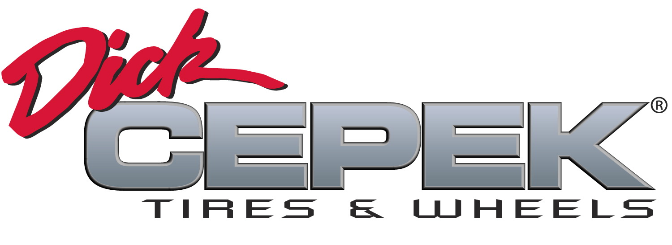
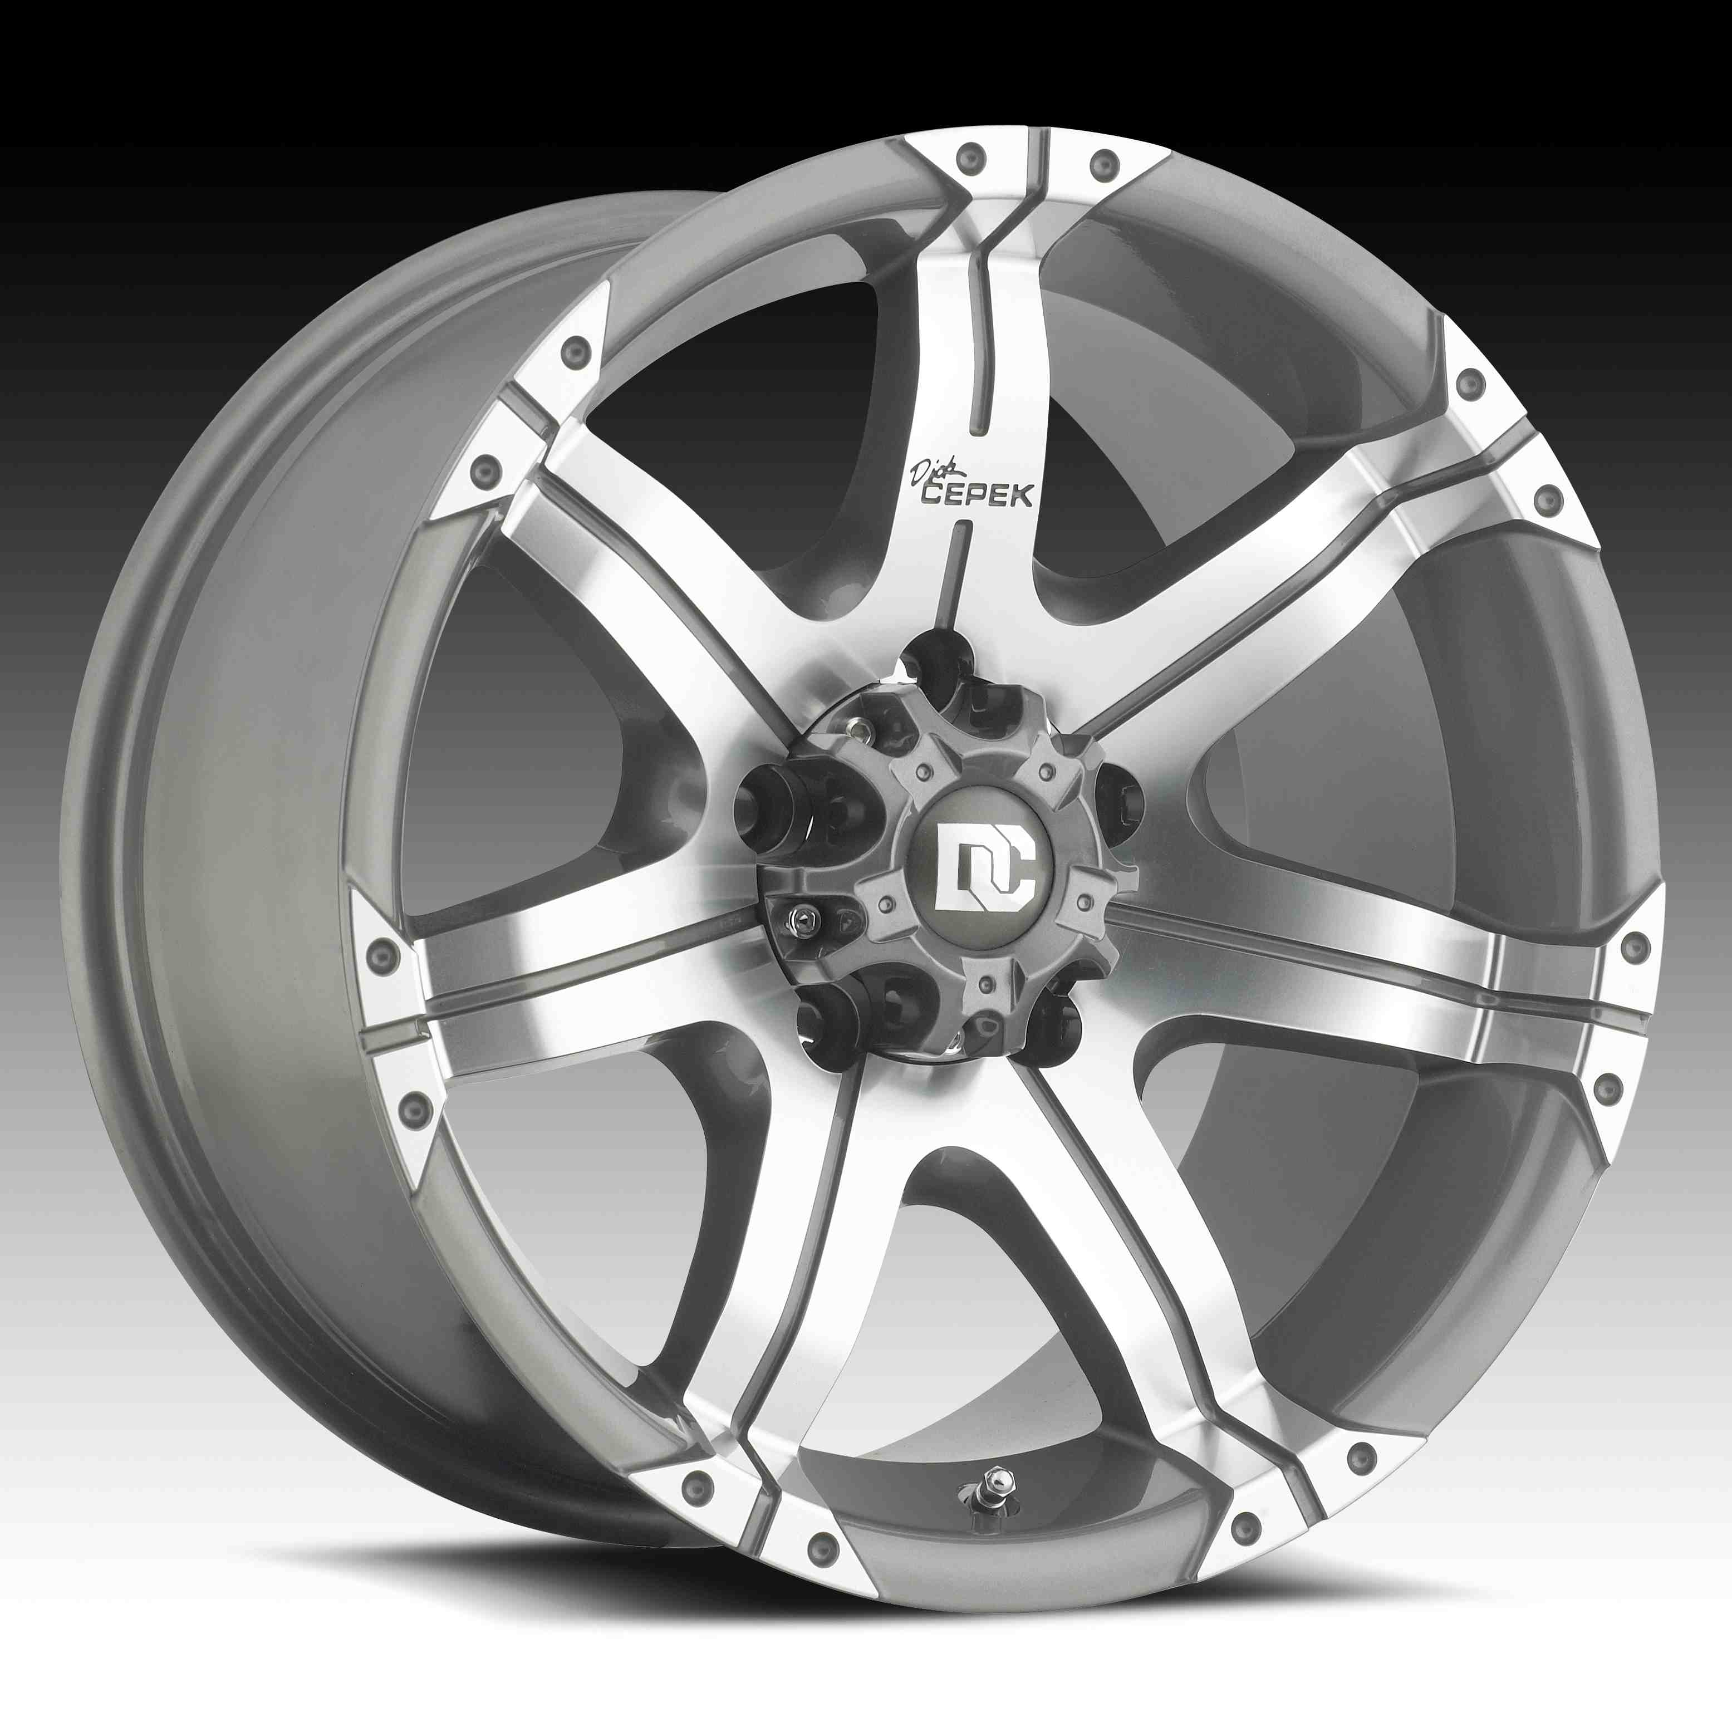

Contact :

DICK CEPEK TIRES
& WHEELS
4600 Prosper Drive
Stow, OH 44224
Don Sneddon, Advertising Manager
800-222-9092 ext. 3750
or 330-928-9092
www.dickcepek.com

DICK CEPEK TIRES & WHEELS OFFERS THE GUN METAL 7 WHEEL

STOW, OH – The Gun Metal 7 wheel from Dick Cepek is a distinctive gray and machined aluminum wheel with a seven-spoke design. It is available in popular 17- and 20-inch sizes in both low and high offsets for lifted and non-lifted trucks and SUV’s. It has a tough glossy clear coat that provides a layer of UV protection for superior durability and ease of care, even in the harshest climates.

“The Gun Metal 7 is the first seven-spoke wheel in the line and it’s a great design,” said Ken Warner, VP of Marketing, Dick Cepek. “It’s a tough wheel, which truck owners need, with a unique, smooth, gun metal gray finish that delivers the ultimate style.”

Together with the incredibly popular Dick Cepek radial-tire line, the Dick Cepek Gun Metal 7 wheel offers a great new option for truck and SUV owners. For more information, visit http://www.dickcepek.com/wheels.php?item=GunMetal7.

About Dick Cepek Tires & Wheels
Founded in 1963 by off-road enthusiast Dick Cepek, the Dick Cepek brand has always taken great pride in providing quality on and off-road products for truck, SUV and 4x4 owners. From its humble beginnings to its high-tech tire manufacturing facilities around the country today, the Dick Cepek legend lives on in the quality products that bear his name. For more information, visit http://www.dickcepek.com

