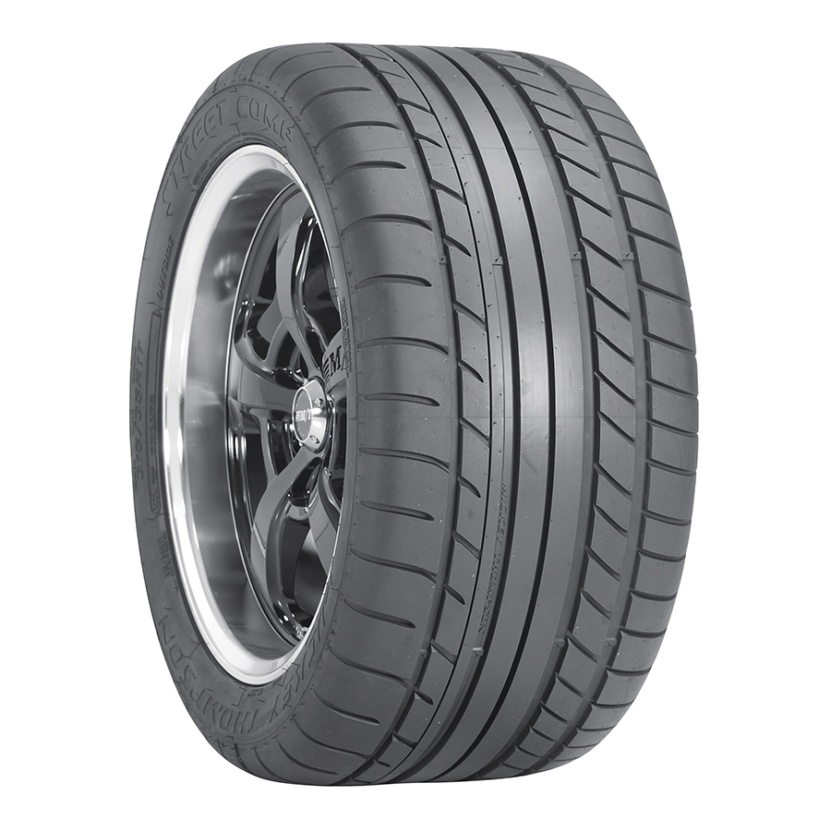
Contact :
MICKEY THOMPSON
PERFORMANCE TIRES & WHEELS
4600 Prosper Drive
Stow, OH 44224
Don Sneddon, Advertising Manager
800-222-9092 ext. 3750
or 330-928-9092
dsneddon@mickeythompsontires.com
http://www.mickeythompsontires.com/

MICKEY THOMPSON PERFORMANCE TIRES & WHEELS OFFERS A SUPER WIDE STREET COMP TIRE FOR 17-INCH WHEELS

STOW, OH – Oct. 30, 2013 – The Street Comp ultra-high performance (UHP) tire from Mickey Thompson utilizes Mickey Thompson’s legendary tire technology in a street tire that’s perfect for today’s late model American muscle cars and more. Now offered in a super wide 315x35R17 for Ford Mustang with a 17-inch wheel, the Street Comp is now available in 19 popular sizes.

“The Street Comp was designed with today’s late model American muscle cars in mind,” said Ken Warner, VP of Marketing, Mickey Thompson. “These cars have higher horsepower and torque and need a UHP street tire with superior response and ride comfort. This new wide size is the perfect choice for the new model Mustang, and reflects the incredible spirit of this iconic muscle car.”

The Street Comp has a UTQG 300 AA A treadwear rating and a unique tread design for superior performance and responsive handling in both wet and dry conditions. For more information, visit http://www.mickeythompsontires.com/street.php?item=StreetComp. (See size chart on page two.)

About Mickey Thompson Performance Tires & Wheels
Max-Trac Tire Co., Inc., dba Mickey Thompson Performance Tires & Wheels, markets racing and high-performance tires and wheels for street, strip, truck, and off-road applications. The company was founded in 1963 by racing legend Mickey Thompson and is headquartered in Stow, Ohio, USA. For more information, visit http:/www.mickeythompsontires.com/.

