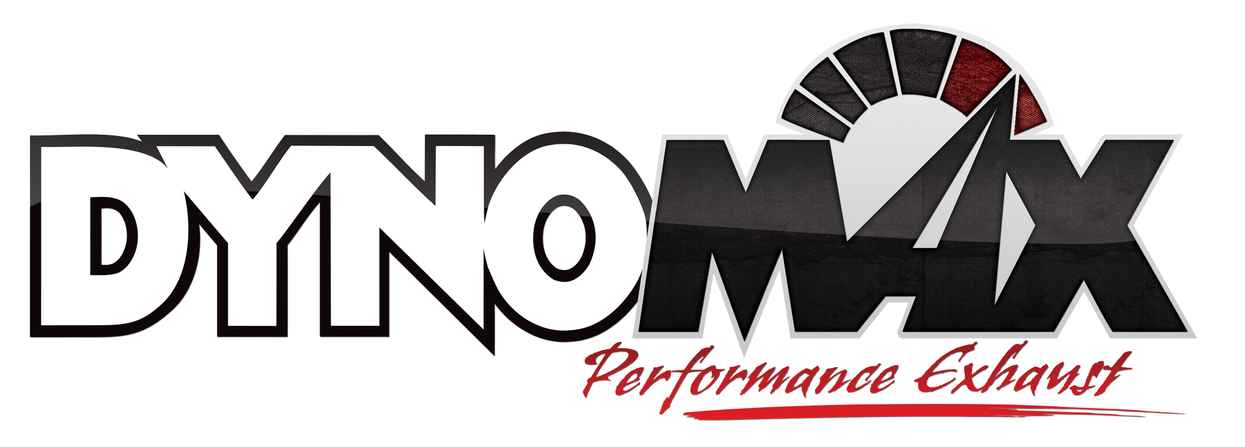
For More Information:

Christine Bowser, Pinnacle Media
(330) 688-3515 chrissy@pinnmedia.com

FOR IMMEDIATE RELEASE

New Jeep System Added to DynoMax® Performance Exhaust Line

New Exhaust System Features Super Turbo™ Muffler,
Posts Horsepower and Torque Improvements During Dyno Testing

Los Angeles, Jan. 21, 2014 – DynoMax® Performance Exhaust has launched a new performance axle-back exhaust system for 2007-2011 Jeep Wrangler JK 3.8L V6 and 2012-2014 Jeep Wrangler JK 3.6L V6 models. Available now at performance retailers nationwide, the new DynoMax Jeep system helps increase torque by 11-ft.-lbs. and boost performance by up to 12 horsepower.
The new DynoMax Jeep system (p/n 39528) has a Super Turbo™ muffler assembly at its core. The DynoMax Super Turbo muffler is constructed from stainless steel and offers a mild sound level with a true performance tone and minimal resonation. Each system includes a cover for the muffler constructed from polished, 304-grade stainless steel.
The new kit includes 2.5-in. stainless steel, mandrel-bent piping to help extend protection against corrosion and a 4-in. stainless steel, slant-cut tip.
The new exhaust system includes all necessary hardware, hangers, clamps and other accessories as well as highly detailed, step-by-step installation instructions. The system is compatible with two- and four-door JK models.
DynoMax Performance Exhaust – a popular brand among Jeep enthusiasts – offers a full complement of Jeep products, including torque- and horsepower-enhancing DynoMax VT™, Super Turbo™ and Ultra Flo™ exhaust systems covering applications 1986 and newer.
A DynoMax Limited Lifetime Warranty and an exclusive 90-Day Performance & Sound Guarantee cover the latest DynoMax Jeep exhaust system. This guarantee allows enthusiasts to try the product for 90 days. If within the first 90 days of ownership the consumer is unhappy for any reason, they can return the product for a full refund of the purchase price. For more information, please visit www.DynoMax.com.
DynoMax is manufactured and marketed by Tenneco. DynoMax is one of North America’s leading brands of dyno-proven exhaust technologies for late-model and classic muscle cars, diesel and gas trucks and SUVs.
For more information, please visit www.DynoMax.com, contact your nearest DynoMax supplier or call 1-734-384-7806. For the name and location of your nearest DynoMax retailer, check out the Dealer Locator at www.DynoMax.com.
Tenneco Inc. (NYSE: TEN) is a $7.4 billion global manufacturing company with headquarters in Lake Forest, Illinois and approximately 25,000 employees worldwide. Tenneco is one of the world’s largest designers, manufacturers and marketers of clean air and ride performance products and systems for automotive and commercial vehicle original equipment markets and the aftermarket. Tenneco’s principal brand names are Monroe®, Walker®, XNOx™ and Clevite® Elastomer.
###

