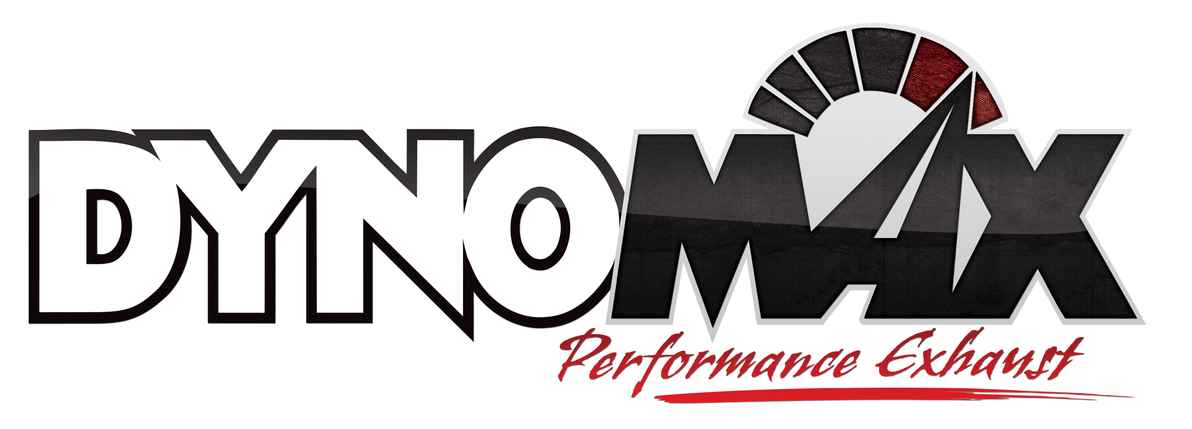
For More Information:

Christine Bowser, Pinnacle Media
(330) 688-3515 chrissy@pinnmedia.com

FOR IMMEDIATE RELEASE

DynoMax® Launches Performance Exhaust System for
2014 Chevrolet Silverado/GMC Sierra Trucks

Los Angeles, Jan. 21, 2014 – DynoMax® Performance Exhaust – a leader in performance exhaust systems for cars, trucks and SUVs – has launched two new systems for 2014 Chevrolet Silverado/GMC Sierra 1500 trucks. The single- and dual-exhaust systems are available now at performance retailers nationwide.
The DynoMax 2014 Chevrolet Silverado/GMC Sierra 1500 5.3L V8 crew cab short bed (143.5-in. wheelbase)/double cab standard bed (143.5-in. wheelbase)/crew cab standard bed (153-in. wheelbase) systems include two options, a single- and dual-exhaust design, for discerning drivers.
Both of the new systems include the popular DynoMax Ultra Flo™ welded muffler, a stainless steel, fully welded design with straight-through internal piping to help ensure unrestricted exhaust flow and reduced backpressure. The muffler design is dyno-proven to flow up to 2,000 SCFM and to support up to 2,000 horsepower. Each Ultra Flo welded muffler includes CRF (Continuous Roving Fiberglass) technology to absorb unwanted interior resonance while maintaining a deep performance tone.
The single-exhaust system (p/n 39529) includes 3-in. mandrel-bent, stainless steel tubing for loss-free flow and extended durability and a 4-in. outlet buffed and polished, 12-in. overall length, stainless steel slant cut tip. The dual-exhaust system (p/n 39530) features 2.5-in. mandrel-bent, stainless steel tubing and a 3-in. outlet buffed and polished, 12-in. overall length, stainless steel slant cut tip.
Both systems include all necessary OE-like hangers, brackets and accessories. Detailed, full-color installation instructions are included for a fast and easy install.
The new DynoMax Silverado/Sierra systems are covered by a DynoMax brand Limited Lifetime Warranty and an exclusive 90-Day Performance & Sound Guarantee. The 90-Day Performance & Sound Guarantee allows enthusiasts to try the product for 90 days. If within the first 90 days of ownership the consumer is unhappy for any reason, they can return the products for a full refund of the purchase price. For more information, please visit www.DynoMax.com.
To learn more about the DynoMax Silverado/Sierra systems or other performance exhaust products from DynoMax, please visit www.DynoMax.com, contact your nearest DynoMax supplier or call 1-734-384-7806. For the name and location of your nearest DynoMax retailer, check out the Dealer Locator at www.DynoMax.com.
Tenneco Inc. (NYSE: TEN) is a $7.4 billion global manufacturing company with headquarters in Lake Forest, Illinois and approximately 25,000 employees worldwide. Tenneco is one of the world’s largest designers, manufacturers and marketers of clean air and ride performance products and systems for automotive and commercial vehicle original equipment markets and the aftermarket. Tenneco’s principal brand names are Monroe®, Walker®, XNOx™ and Clevite® Elastomer.
###

