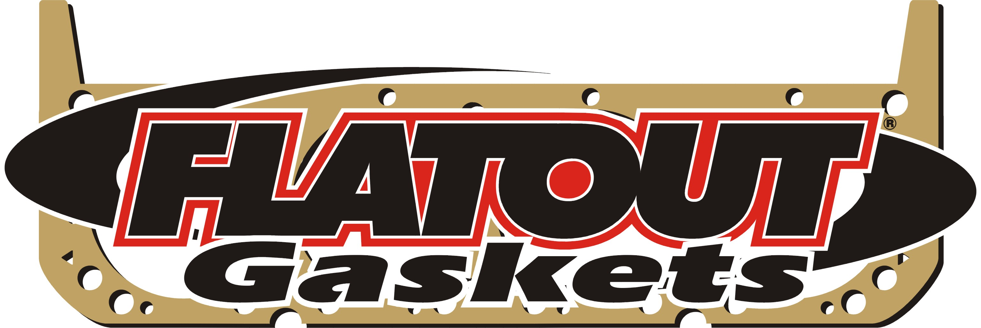

Mundelein, IL. - Flatout Gaskets is pleased to announce the release of their 2005 Flatout Gasket catalog – 2005.01

The new catalog covers popular performance engine applications. Rubber Coated Copper (RCC) and SaberSeal MLS head gaskets, intake and header gaskets along with specialized, low volume and custom applications are also available to enthusiasts, racers and engine builders.

For more information or to have a new Flatout Gasket catalog sent directly to you, please call Toll-Free - 877.837.9200 or go to www.flatoutgroup.com.

